Chapter 11

Managing the Supply Chain

**Background**

Supply-chain management remains one of the hottest topics in business today, as companies continue to search for effective ways to drive costs out of the supply chain. Many schools offer one or more courses or even full programs devoted to the topic. Chapter 11 provides a good overview of some of the major supply-chain management issues. Slides 11-41 through 11-44 identify important opportunities for managing supply chains. The main theme that instructors should emphasize is that effective supply-chain management is all about cooperation among members of the chain through close partnerships with suppliers, sharing information throughout the supply chain, etc. Optimizing decisions for the whole supply chain instead of for each firm individually creates value, and the extra value creates a win-win situation as long as the benefits are shared among the supply chain members.

**Class Discussion Ideas**

1. The world’s largest retailer, Wal-Mart, owns and manages its own fleet of trucks. The company has often received praise for its distribution capabilities. The practice, however, seems to represent a stark contrast to the practice of outsourcing not only shipping, but other logistics operations to third-party logistics providers. Discussion could address the advantages and disadvantages of these different policies. Under what conditions would it make sense for a firm to own and manage its own trucking operation?

2. Multi-facility companies must decide whether to purchase goods centrally or let each site purchase on its own. Instructors could have the students try to identify the advantages and disadvantages of centralized purchasing. Some advantages include: (1) more ability to obtain quantity discounts, (2) reduced duplication of effort, (3) economies of scale in purchasing activities, and (4) potential risk pooling benefits. Some disadvantages include: (1) potential extra material handling, (2) potential longer lead times, (3) local site needs being ignored, and (4) loss of control for local managers who are judged on profit or cost.

**Active Classroom Learning Exercises**

1. Split the class into small groups. Have the groups choose a firm with which they are familiar and list and describe in detail some ethical issues the firm might face in managing its supply chain activities. Have each student group report its ideas to the whole class.

2. Play the Beer Game (citation provided in Other Supplementary Material below). This well-known game has been played in top business schools throughout the world, and even various automated versions of the game exist. The game effectively illustrates the bullwhip effect, as student supply chains often create large fluctuations in inventory and backorder levels after about 20 rounds of the game have been played. If managed well, this game can represent one of the in-class highlights of the course for students. The game takes at least 75 minutes and works better if a full two hours can be devoted to it. Tip: type out and paste instructions for each step on the game boards themselves.

**Company Videos**

1. *Darden’s Global Supply Chains (8:12)*

Darden Restaurants manages four distinct supply chains in support of its franchise restaurants: (1) Central Distribution for Smallware (nonfood items), (2) Independent Supply Chain (local purchasing for items such as dairy products), (3) Darden Direct Distribution (Darden owns and manages its inventory positions while using third-party logistics providers for warehousing and distribution), and (4) Seafood Warehousing Network (utilizing warehouses throughout the world where the seafood is harvested). The seafood network stores as much as $150 million in inventory at any point in time in order to protect against potential supply disruptions. Distribution centers are located to try to find the proper balance between cost and service. Concerning suppliers, Darden works to develop partnering, win-win relationships, and it strives to find the proper balance between supplier needs and customer needs.

Prior to showing the video, instructors might ask students to think about how Red Lobster and Olive Garden restaurants might procure and receive all of their supplies (food and non-food). Afterwards, discussion could begin with exploring why having four different supply chains makes sense for these restaurants. This could evolve into a centralized vs. decentralized purchasing discussion. Would an individual restaurant manager want to purchase any of his or her own materials or food? If so, which ones? What about other types of large businesses with many outlets (Jiffy Lube, Target Stores, Great Clips Hair Salons, Starkbucks, The UPS Store, etc.)? Would any of those be particularly appropriate to utilize local purchasing?

A different discussion thread could address the environmental impact of Darden’s global sourcing of fresh fish. As one article in Orlando stated, “If fish were intended to fly, they wouldn’t be fish.” Darden’s huge claim to serve non-frozen (i.e., fresh) fish means that the carbon footprint on everyone’s meal is enormous. The firm is very sustainability-oriented in many other activities that it engages in, but the volumes involved in Darden’s fresh fish sourcing strategy certainly contribute to the global warming problem. Discussion could focus on what Darden’s responsibility, if any, should be with regard to its potential impact on global warming. Should the company be trying any new tactics in the long run?

2. *Arnold Palmer Hospital’s Supply Chain (8:08)*

The hospital was originally one of 900 members of a national purchasing group, which had served it well with respect to getting good prices for its supplies. However, when the national purchasing group switched vendors for some products away from Arnold Palmer Hospital’s preferred vendors, the hospital decided to form its own regional purchasing organization, along with seven partner hospitals in Florida. Surprisingly, even with far fewer members than the national organization, the regional group provided a 7% overall cost reduction for Arnold Palmer Hospital, in part due to savings in national membership fees. The regional group has been so effective because it has successfully relied upon trust among member hospitals, who must share patient and forecasting information with each other. Three other supply chain issues emerge from the video. First, the medical and nursing staff members at the hospital actively participate in supply chain management efficiency improvement efforts. Second, when possible, the hospital tries to focus on few suppliers to form long-term relationships. Third, the regional purchasing group has successfully integrated three tiers of suppliers in some of its supply chain management initiatives.

Prior to showing the video, instructors might ask students about the pros and cons, as a single-facility or small business, of joining a large purchasing group from which to purchase most major supplies. Afterwards, discussion could flush out the gains that Arnold Palmer Hospital attained by belonging to a purchasing group, but also the challenges that it faced. Instructors could ask students why prices for certain supplies seemed to decrease when the hospital joined a much smaller purchasing group—the video only touched on this issue briefly, leaving us to speculate a bit about some of the reasons why (perhaps guarantees of sole supplier status, cheaper shipping cost, or being better able to accommodate certain supplier needs are all possibilities). An issue that is not addressed in the video but comes to mind about hospitals is the question of why this hospital cares so much about getting supplies at a low cost. To the extent that insurance companies and Medicare likely pay for the cost of supplies via hospital bills to patients, why should this hospital care? Health care costs seem to rise every year and consumers keep paying because they seldom have other options to remain healthy. Does the existence of competition play a role? Do insurance plans and Medicare pay a flat reimbursement fee per procedure, regardless of actual hospital cost? If so, then lower purchasing costs would definitely help the hospital.

3. *Supply-Chain Management at Regal Marine (9:58)*

This video provides information about both ends of Regal Marine’s supply chain: the suppliers and the distributors. The firm strives to form *partnering* relations with its major suppliers. Regal’s forecasts are regularly communicated with its partner suppliers, and Regal expects these firms to implement continuous improvement policies. The firm has worked hard to reduce inventory. In many cases, vendors deliver raw materials weekly for use that week. Regal has a vendor managed inventory relationship with some suppliers, which has eliminated order taking, receiving, and warehousing of those products. To help ensure quality, Regal chooses to partner with suppliers that are or are trying to become ISO 9000 certified. Regal is a member of a 12-company purchasing group that allows member firms to attain volume discounts from suppliers, leveling the playing field against the big conglomerate boat manufacturers. On the distribution end, Regal searches for first-class dealers that are mature and will represent the products well. Potential dealers are evaluated on location, maturity of sales force, market share, and perhaps most importantly, customer satisfaction index. Regal can attract first-class dealers by striving to produce best-in-class products.

Prior to showing the video, instructors ask the students to think about the task for manufacturing companies of finding the best dealers through which to sell their products. What factors should they take into consideration? Following the video, student input could be compared with the factors with which Regal Marine focuses. Once a dealer is chosen, how should that relationship be monitored and maintained over time? At what point should a manufacturer search for a new dealer? On the purchasing side, the video gives a nice example of some suppliers physically entering the plant to take orders, returning two days later with the proper parts, and not transferring title until the boat is actually finished (all a form of vendor managed inventory (VMI)). Instructors could ask students to identify the pros and cons for both Regal Marine and for the vendors of such a VMI system. Finally, the ISO 9000 requirement for suppliers ties in nicely with material in Chapter 6 of the book. Instructors could point out that ISO 9000 certification appears to be an order qualifier for potential suppliers of Regal Marine. A brief class discussion could attempt to identify pros and cons for Regal Marine of implementing such a policy.

**Cinematic Ticklers**

1. *The Simpsons, Season 10: “Maximum Homerdrive,”20th Century Fox Video, 2007 (1998-1999)*

Homer gets to be a truck driver in this episode.

**Presentation Slides**

INTRODUCTION (11-1 through 11-10)

Slides 9-10: This information on Darden can be supplemented by mentioning the common characteristics of all four supply channels: (1) supplier qualification, (2) product tracking, (3) independent audits of suppliers, and (4) just-in-time delivery.



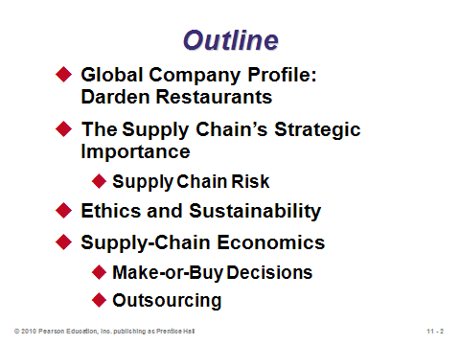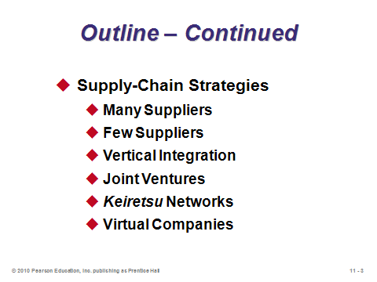

**11-1** **11-2** **11-3**

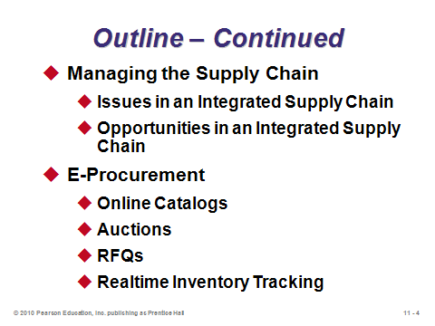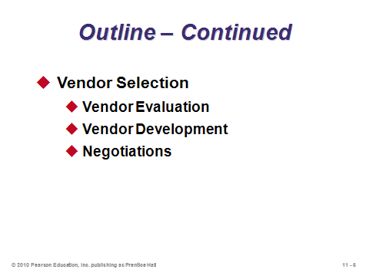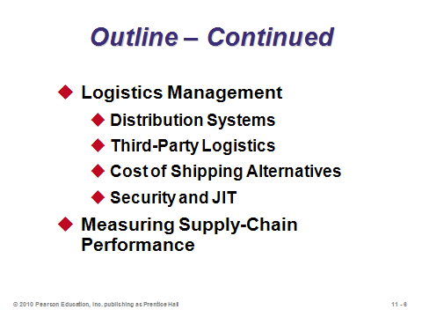

**11-4 11-5 11-6**

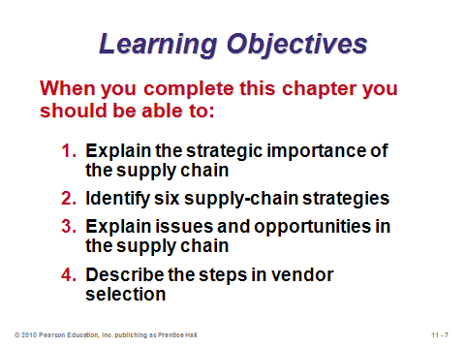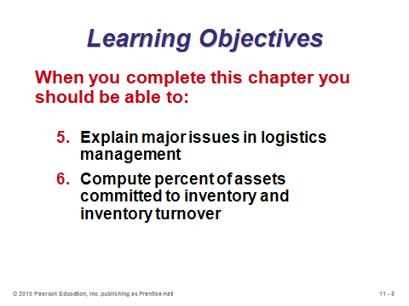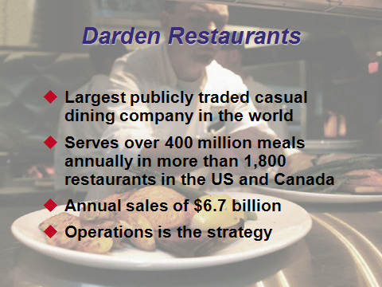

**11-7 11-8 11-9**

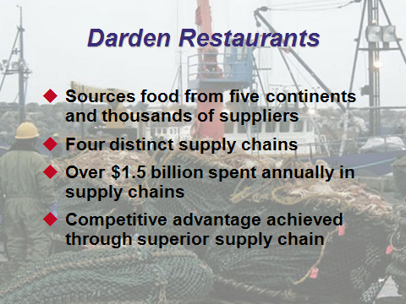

**11-10**

THE SUPPLY CHAIN’S STRATEGIC IMPORTANCE (11-11 through 11-26)

Slide 12: The key term in this definition is *integration*. Effective supply chain management is all about getting all members of the supply chain working together as though they were one vertically integrated company. Mathematically, this suggests a global (across the supply chain) optimization strategy, as opposed to a collection of local (firm-only) optimization strategies.

Slides 13-14: The activities listed in Slide 13 are implied by the Beer Supply Chain shown in Slide 14.

Slides 15-17: These slides reproduce Table 11.1 from the text. We see here another example of how important it is to clearly define and disseminate the firm’s strategy to all employees, as the strategy dictates very different supply chain policies that should be followed.

Slides 18-19: Along with all of the upsides of creating partnerships with supply chain members come the inherent risks of giving up certain control and depending on others (Slide 18). The use of global supply networks compounds the risks by introducing political and currency risk, along with the added complexity that managing global networks entails. The reliability and quality of foreign suppliers may be more difficult to determine up front and monitor over time. Therefore, proper risk management becomes crucial to survival (Slide 19). Management must mitigate and react to disruptions in (1) *processes* (raw materials and component availability, quality, and logistics), (2) *controls* (management metrics and reliable secure communication for financial transactions, product designs, and logistics scheduling), and (3) *environment* (customs duties, tariffs, security screening, natural disaster, currency fluctuations, terrorist attacks, and political issues).

Slide 20: This slide covers some risk management measures taken by selected companies (p. 422): *McDonald’s*—developed independently owned supply plants in Russia to keep its transportation costs and handling times low and its quality and customer-service levels high; *Ford*—developed a global network of few but exceptional suppliers; *Darden Restaurants*—third-party audits on suppliers; *Boeing*—transmits engineering, scheduling, and logistics data to Boeing facilities and its suppliers; *Hard Rock Café*—franchises and licenses (instead of owns) when the political and cultural barriers seem significant; and *Toyota*—has two suppliers for each component in case of natural disasters.

Slides 21-22: Opportunities for ethical violations abound within supply chain management. On a personal level, temptations of bribery and kickbacks must be resisted. Within the supply chain, more and more companies are being held accountable for unethical actions of their suppliers. Finally, as supply chain management deals with the entire process from raw materials to use and final disposal of products, firms must be aware of their environmental impact and should support the conservation and renewal of resources.

Slides 23-26: These slides reproduce Table 11.2 from the text, which identifies the principles and standards of ethical supply management conduct as developed by the Institute for Supply Management. It should be noted that anyone working as a buyer for a governmental organization typically has large number of additional regulations that they must adhere to (e.g., soliciting bids from a certain number of minority-owned businesses, receiving at least a certain number of bids per contract, etc.). Furthermore, instructors should point out that the word “appearance” shows up several times in these standards. It’s not enough to avoid the unethical act—there should not even be any *appearance* of impropriety.

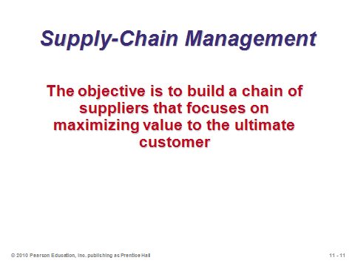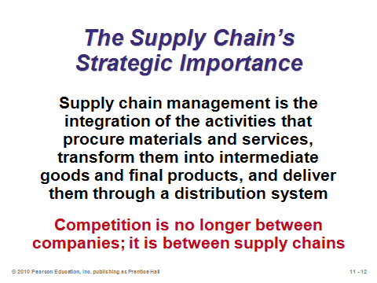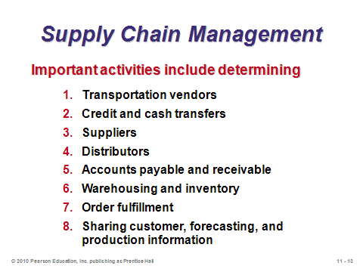

**11-11 11-12 11-13**

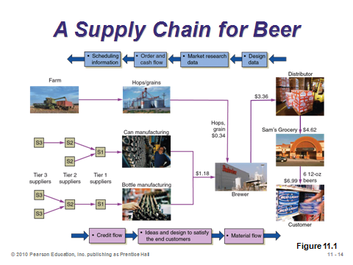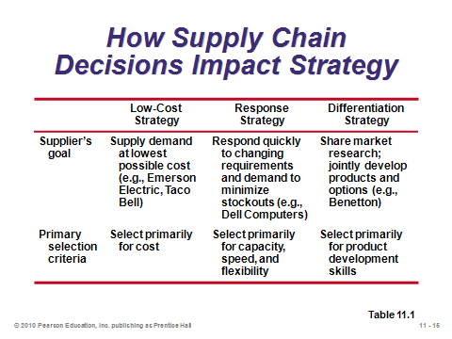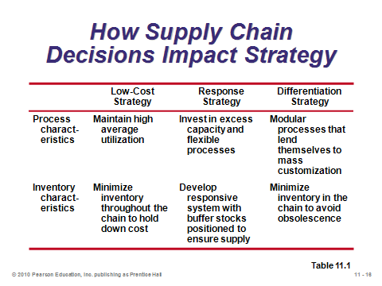

**11-14 11-15 11-16**

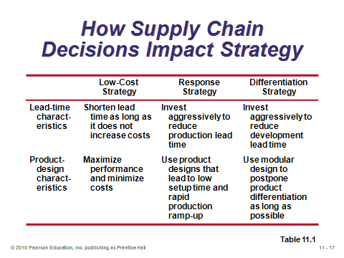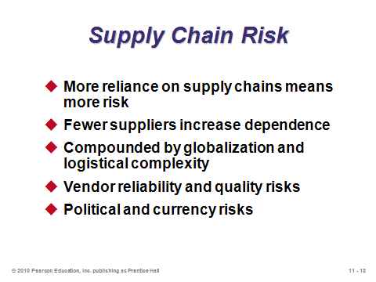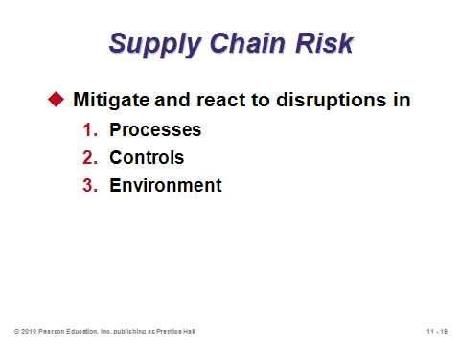

**11-17 11-18 11-19**

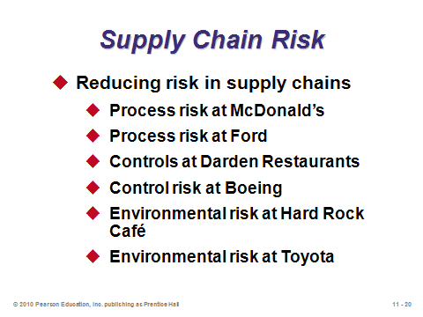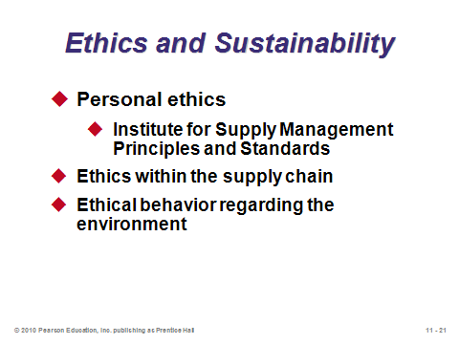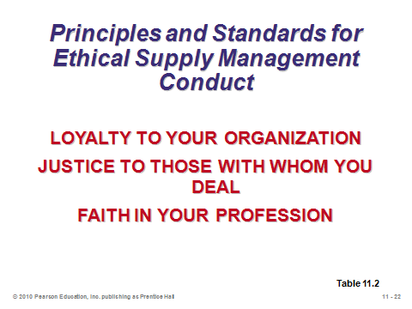

**11-20 11-21 11-22**

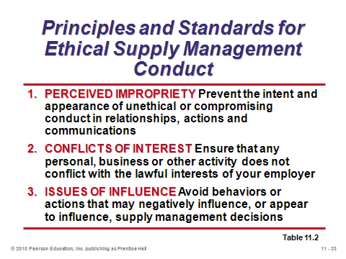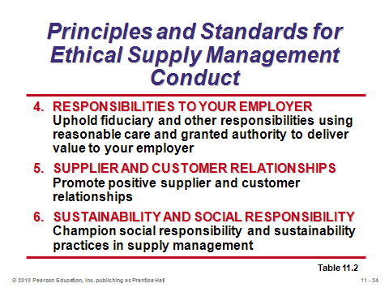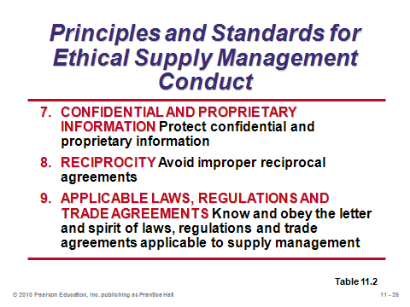

**11-23 11-24 11-25**

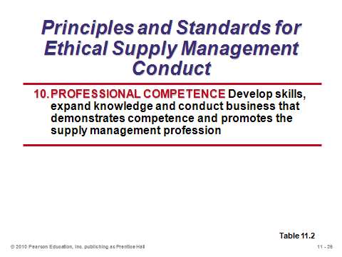

**11-26**

SUPPLY-CHAIN ECONOMICS (11-27 through 11-30)

Slide 27: Using selected data from Table 11.3 in the text, this kind of information is often used when first introducing the importance of supply chain management. With such a huge portion of revenue devoted to the supply chain, proper control of supply chain costs can ensure success for an organization, and vice-versa.

Slide 28: From Example 1 in the text, this illustrates how it is often much easier to increase profit by improving supply chain efficiency than it would be by having to increase sales. This is one reason that supply chain management receives so much attention.

Slides 29-30: These two slides distinguish the slight difference between make-or-buy decisions vs. outsourcing. Firms are outsourcing more and more support (non-production) functions, such as payroll and call centers. Outsourcing is covered in detail in the supplement to Chapter 11.

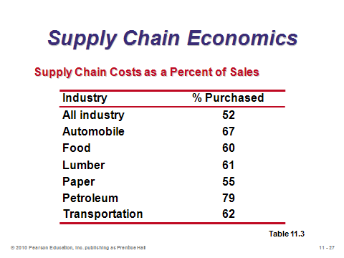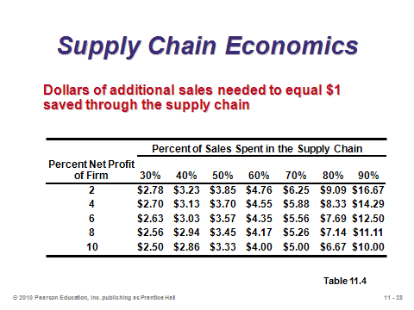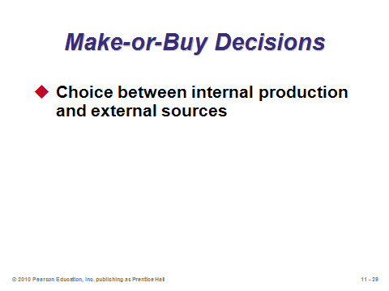

**11-27 11-28 11-29**

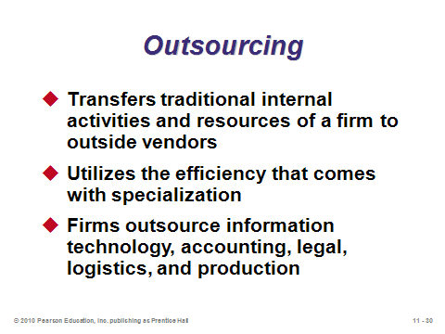

**11-30**

SUPPLY-CHAIN STRATEGIES (11-31 through 11-38)

Slide 31: This slide identifies very different approaches to managing the supply base, which are detailed in the following set of slides.

Slide 32: The “many suppliers” approach is considered to be the “old” or “unenlightened” method for selecting suppliers, but it may still make sense for certain commodity products or for firms who practice an extreme low-cost strategy. These are called “arms-length” transactions, and firms may switch suppliers frequently.

Slide 33: The “few suppliers” approach is considered to be a more “enlightened” method for selecting suppliers, and many top companies have been aggressively working to reduce their respective supply bases. It can be nearly impossible to “work together” in the supply chain integration sense if dealing with many suppliers for the same components. When successfully implemented, the few suppliers approach creates win-win opportunities for all parties.

Slides 34-35: These slides describe vertical integration. Slide 34 reproduces Figure 11.2 from the text, which provides examples of vertical integration in three industries. Importantly, vertical integration works in both directions, including taking over the distribution network. Clearly, the internet has allowed many manufacturers to open up new direct sales channels to customers. Vertical integration is in many ways the opposite of outsourcing; thus, outsourcing’s recent popularity implies that we’re seeing less vertical integration than we used to. Certainly for some products, such as paper mills, vertical integration makes perfect sense. Some of the giant South Korean companies have a fascinating history of growth through a substantial effort towards both vertical and horizontal integration.

Slide 36: Joint ventures can represent a nice way to gain the benefits of partnering while retaining independence and being in a relationship that is easier to dissolve.

Slide 37: *Keiretsu* networks come from Japan, and may include banks as well. In addition to cross-ownership and loans among members, in many cases officers of some companies serve on the board of directors of other firms within the network.

Slide 38: In a virtual company, the supply chain is the company. In some sense, a virtual company takes delegation to the limit. Several firms have become very profitable by using this strategy. Some critics argue that an economy that becomes full of “hollowed out” organizations that do not make anything themselves carries significant risk and does not represent a strong, stable economy. This concern could be addressed in a short class discussion.

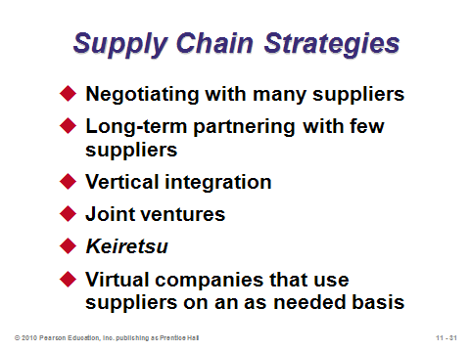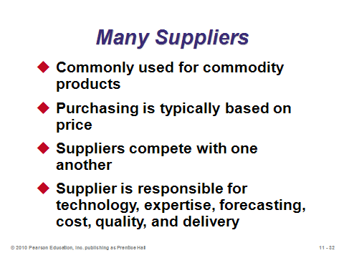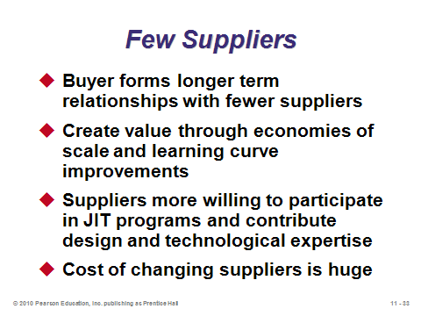

**11-31 11-32 11-33**

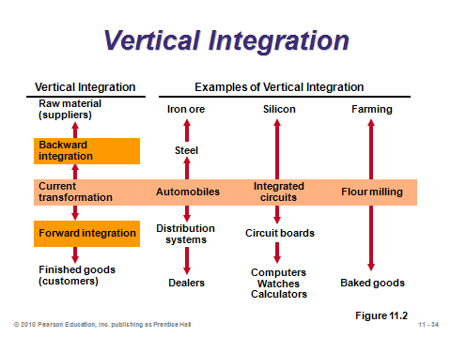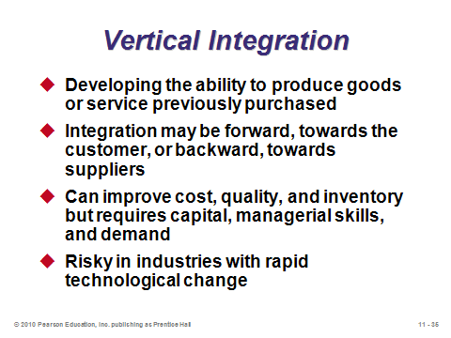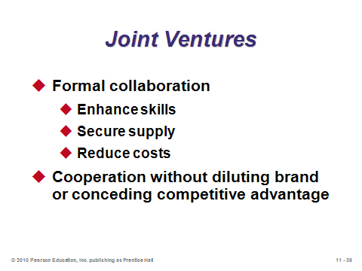

**11-34 11-35 11-36**

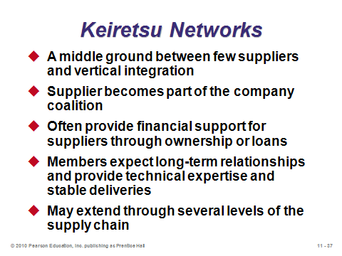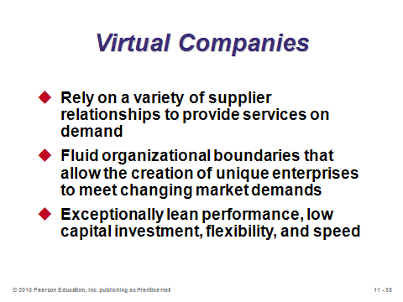

**11-37 11-38**

MANAGING THE SUPPLY CHAIN (11-39 through 11-44)

Slide 39: This slide emphasizes three important characteristics to have for a supply chain to act like an integrated company, ready to compete as one against other supply chains.

Slide 40: All three of the bullets on this slide contribute to the bullwhip effect. All three are related in the sense that such practices fail to take into account their impact on the other supply chain members. The Beer Game (referenced above) represents an outstanding way to illustrate how such thinking can generate a bullwhip effect in a short period of time.

Slides 41-44: Each of these 11 items represents opportunities for effective management in the supply chain. They can all help to minimize the bullwhip effect. Thus, these slides are among the most important in this chapter. Slide 41: (1) accurate pull data are generated by sharing point-of-sales information and computer-assisted ordering; (2) lot size reduction occurs when the benefits of large orders are diminished (e.g., providing discounts based on annual volume rather than units per order or reducing the cost of placing orders); (3) single-stage control of replenishment implies designating one supply chain member to monitor and manage inventory for the whole system, and (4) VMI has vendors maintaining inventory for the buyers, often physically doing so directly in the buyers’ facilities (an example might be a soft drink company keeping the shelves stocked weekly at a local convenience store). Slide 42: (1) CPFR involves members of the supply chain sharing planning, forecasting, and inventory information; (2) blanket orders are long-term commitments with suppliers to purchase items, which are later delivered upon receipt of a shipping requisition; and (3) standardization means employing the use of *common components* in different products and across production facilities (firms have saved thousands or even millions of dollars doing this via higher volume discounts and inventory reductions). Slide 43: (1) postponement combines a *make-to-stock* strategy for subassemblies with a *make-to-order* strategy for final products; thus, this can be a way to move towards mass customization (Benetton provided a famous example of postponement by shipping all white sweaters to its distribution centers and dyeing the sweaters there once fashion tastes for the upcoming season are better known); (2) drop shipping involves having suppliers ship certain components or peripherals directly to the customers, without physically going through the selling firm’s hands; (3) a pass-through facility is also known as a *cross dock*—instead of storing incoming inventory for some time in a warehouse, such inventory is directly placed into an outgoing truck, and (4) channel assembly is somewhat like extending postponement downstream in the supply chain. Slide 44 provides an example of RFID. While we are still waiting for the full potential benefits of RFID to be realized, someday it may eliminate the need for any manual receiving documentation to be filled out and it may be able to sum the total bill in a retail customer’s shopping cart in less than a second (while simultaneously providing near-perfect shoplifting detection).

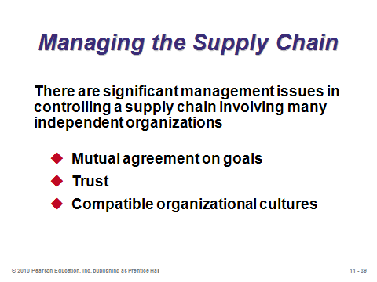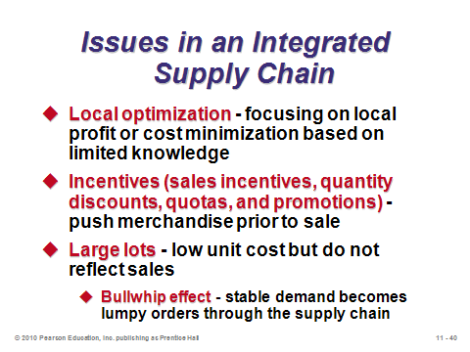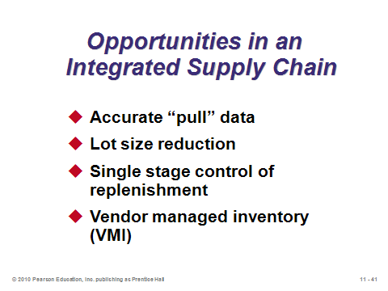

**11-39 11-40 11-41**

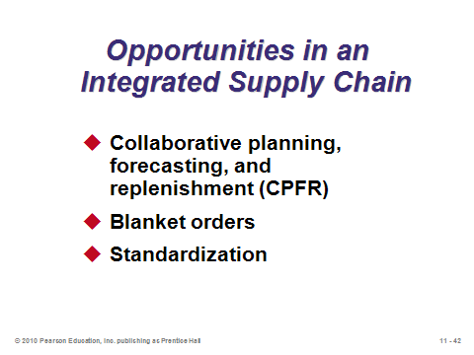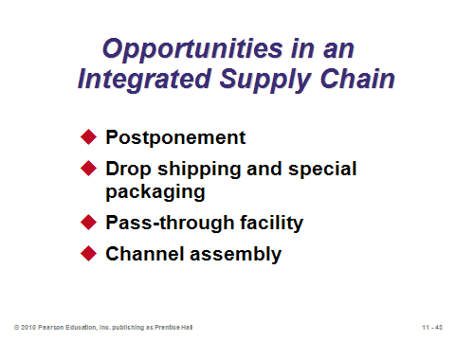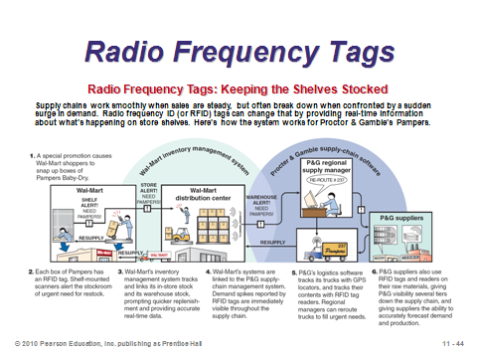

**11-42 11-43 11-44**

E-PROCUREMENT (11-45 through 11-49)

Slides 45-49: This set of slides covers the increasing practice of firms that order items with computers. Online catalogs come in three forms, as identified in Slide 46. Slide 47 identifies several internet trading exchanges, which provide a centralized online system for certain industries and eliminate the need to contact multiple companies one-by-one. Slide 48 describes online auctions, which have become excellent mechanisms for firms to unload excess material or inventory. E-Bay is probably the best known consumer-based example of such auctions. At this point, instructors could ask the students about their experiences with E-Bay or similar auctions. The pros and cons identified there might be relevant for business-to-business auctions as well. Slide 49 describes how e-procurement has streamlined the RFQ process.   
Furthermore, the combination of e-procurement, bar codes, and RFID have made tracking of inventory and individual products much more accurate.

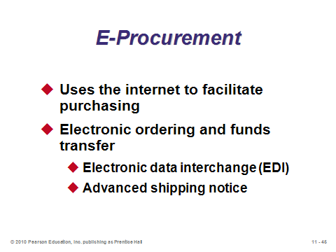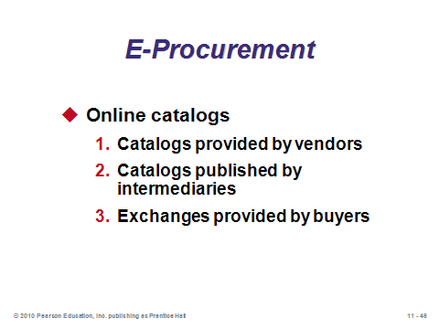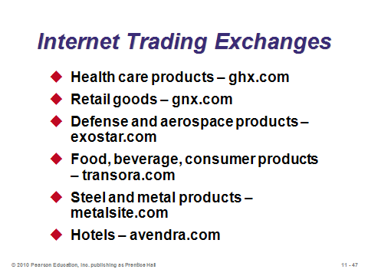

**11-45 11-46 11-47**

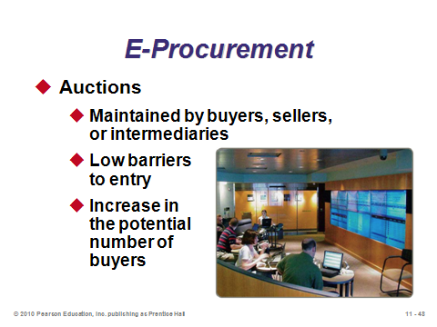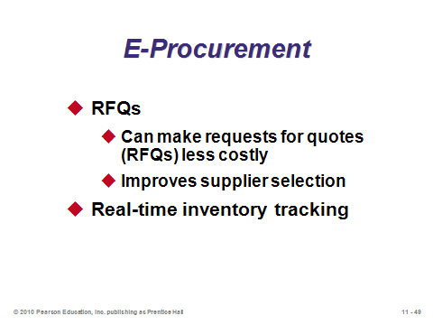

**11-48 11-49**

VENDOR SELECTION (11-50 through 11-52)

Slide 50: Selecting the appropriate vendors can have an enormous impact on quality and production efficiency. A fair amount of research has been and continues to be conducted regarding the supplier selection problem. This is arguably the most important task of a purchasing professional. Vendor development refers to the concept of incorporating selected vendors into the supply chain. Often a large buying firm will essentially provide free consulting services to smaller vendors to help them reach the necessary quality and production levels.

Slide 51: From Example 2 in the text, this slide provides an example of using a weighted-average method to evaluate suppliers. Note the suppliers are often evaluated on far more than simply the price offered.

Slide 52: While most consumer transactions involve no negotiations, most business-to-business transactions do. Even when the same prices are offered to all customers, other terms such as delivery and payment are typically open to negotiation between companies. This slide identifies three typical ways that prices are determined in business-to-business transactions.

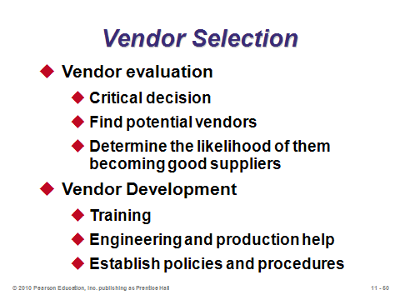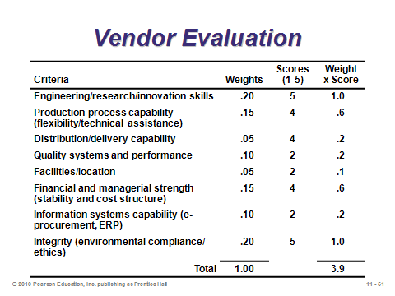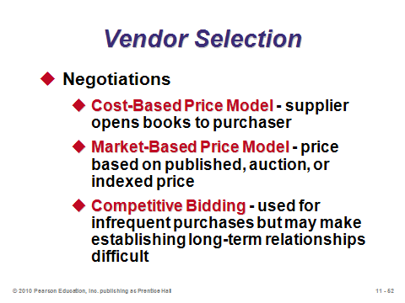

**11-50 11-51 11-52**

LOGISTICS MANAGEMENT (11-53 through 11-61)

Slide 53: The distribution component of supply chain management is covered under logistics management. Companies such as Wal-Mart have attained competitive advantage by implementing outstanding logistics systems.

Slides 54-57: These slides identify the major distribution systems. Trucking is by far the most common, but the others still play a substantial role in some industries. For international shipments, the huge cost savings attained by sending goods by ship instead of plane must be weighed against substantially longer lead times. Instructors might ask if students can think of any “modern” distribution system that is not on the slides—answer: electronic (downloading music, etc.).

Slide 58: This slide describes the concept of third-party logistics, where firms completely outsource their logistics efforts, including, in some cases, their warehousing, assembly, and customs. FedEx, UPS, and DHL have expanded their roles from shipping companies to full-service logistics providers.

Slides 59-60: These slides show how to compute the core tradeoff between the higher cost of a faster shipment method with its savings in pipeline inventory costs. Slide 60 illustrates Example 3 from the text. If the time savings is longer than one day, the same calculation is made but should be multiplied by the number of days of savings.

Slide 61: Instructors could emphasize the statistic from the text stating that some 5% of international container movements are misrouted, stolen, damaged, or excessively delayed. This quote also applies: “Improvements in security may aid JIT, and improvements in JIT may aid security—both of which can improve supply chain logistics.”

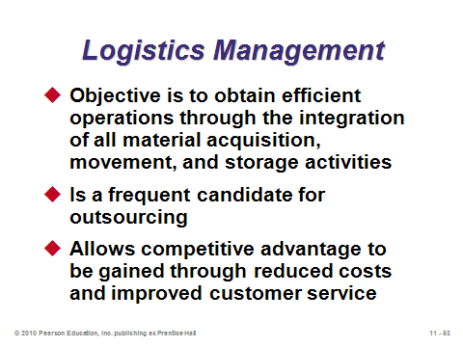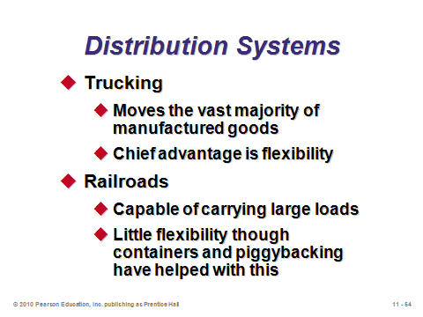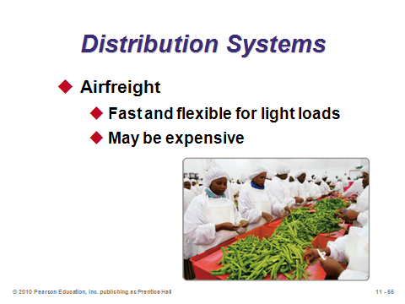

**11-53 11-54 11-55**

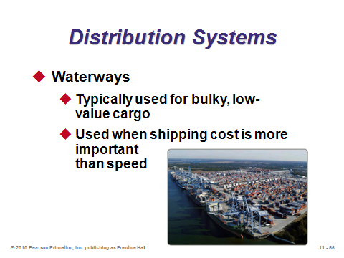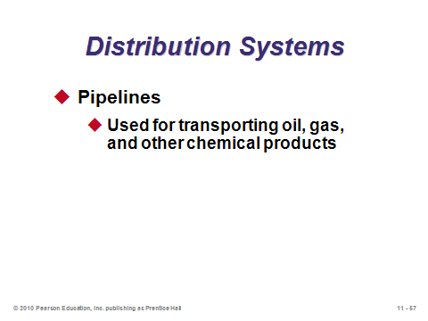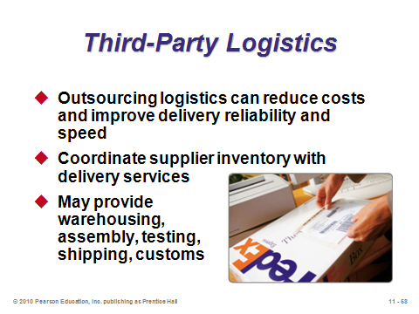

**11-56 11-57 11-58**

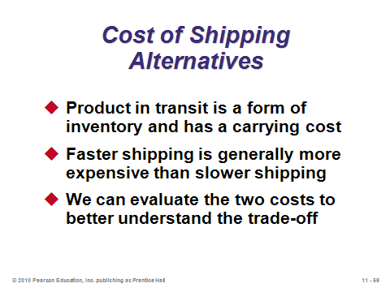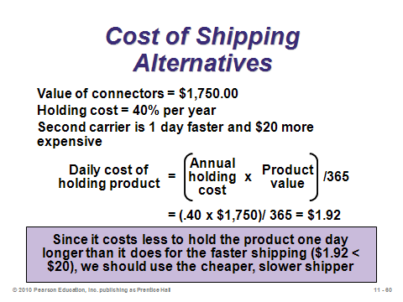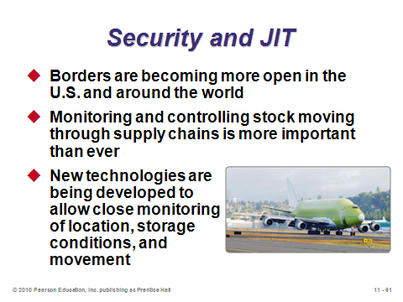

**11-59 11-60 11-61**

MEASURING SUPPLY-CHAIN PERFORMANCE (11-62 through 11-70)

Slide 62: From Table 11.5 in the text, this slide describes common supply chain metrics that focus on procurement and vendor performance issues. The “Benchmark Firms” column represents the performance of typical world-class firms. These values can be good targets for which to strive.

Slides 63-64: These slides focus on the supply-chain metric of *percent invested in inventory* (in general, the lower the better). Slide 63 presents Example 4 from the text. Typical values for four industries are presented in Slide 64 (Table 11.6), along with examples of exceptional performance.

Slides 65-69: The formula for *inventory turnover* is provided in Slide 65, with company examples provided in Slide 66 (Table 11.7). Note how inventory turnover can vary substantially, depending on industry and company conditions. In general, higher turnover is better. Slides 67 and 68 present the inventory turnover calculation from Example 5 in the text. Slide 69 continues the example by also determining the *weeks of supply* (Example 6). In general, a smaller value is better.

Slide 70: Slide 70 presents Figure 11.3 from the text, showing the Supply-Chain Operations Reference (SCOR) model developed by the Supply-Chain Council. Membership in the council (currently about 900 members) costs between $300 and $5000 and provides, among other benefits, access to the process, metric, and best practice data from the SCOR model.

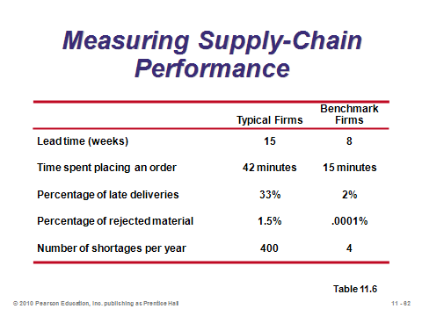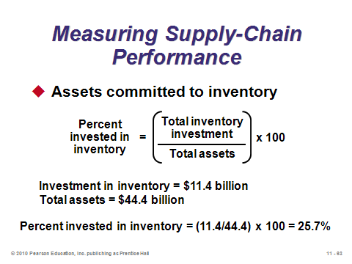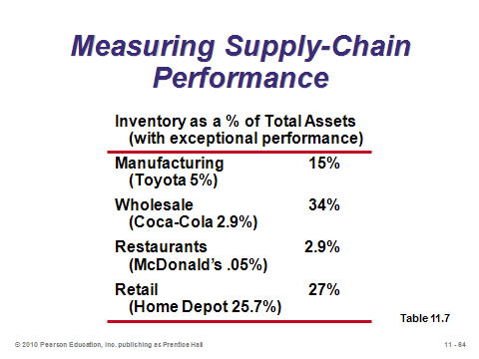

**11-62 11-63 11-64**

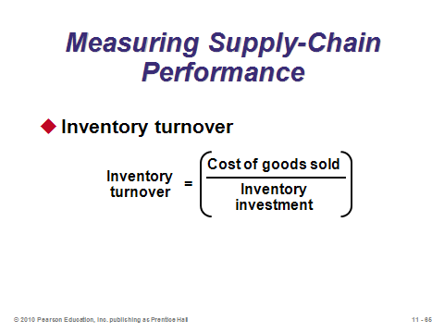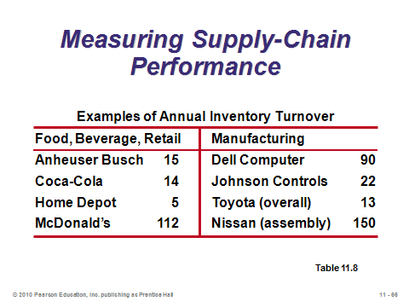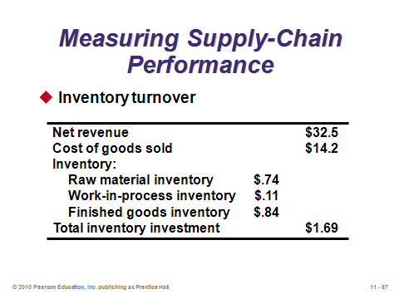

**11-65 11-66 11-67**

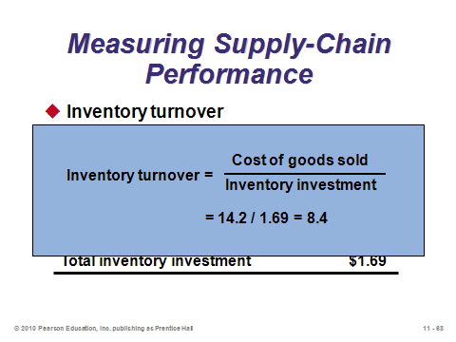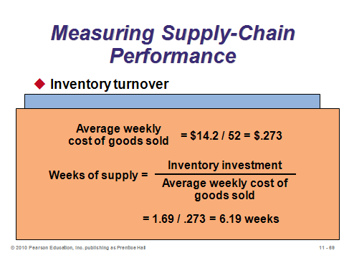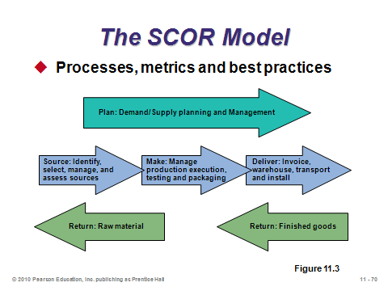

**11-68 11-69 11-70**

**Additional Assignment Ideas**

1. Visit *Purchasing: The magazine for chief procurement officers and supply chain executives* Web site. Browse site for articles on various issues or search the archive. Choose, read, and print out one article and write an executive summary. http://www.purchasing.com/
2. Many companies help certify suppliers. Visit American Supplier Institute: http://www.amsup.com. What types of services are offered?
3. Professional societies, such as APICS, ISM, and CSCMP, offer education and certifications. Describe the professional societies and the programs they offered.

APICS (http://www.apics.org/)

Institute for Supply Management (http://www.ism.ws/)

Council for Supply Chain Management Professionals (http://cscmp.org)

**Additional Case Studies**

Internet Case Study (www.pearsonglobaleditions.com/heizer)

* *Amazon.com*: Discusses opportunities and issues in an innovative business model for the Internet

Harvard Case Studies (http://harvardbusinessonline.hbsp.harvard.edu)

* *Supply-Chain Management at World Co. Ltd*. (#601-072): Illustrates the value of response times and how to reduce response times.
* *Ford Motor Co. Supply Chain Strategy* (#699-198): Evaluation of whether Ford should "virtually integrate" on the Dell Computer model.
* *Sport Obermeyer Ltd*. (#695-022): Examines how to match supply with demand for products with high demand uncertainty.
* *Barilla SpA (A)* (#694-046): Allows students to analyze how a company can implement a continuous replenishment system.
* *Tale of Two Electronic Components Distributors* (#697-064): Examines distributor consolidation and growth of the Internet.

Richard Ivey School of Business (http://cases.ivey.uwo.ca/cases/pages/home.aspx)

* *Supply Chain Management at Wal-Mart* (#9B07D001): In 2006, Wal-Mart, the second largest firm in the world by sales, was looking to improve its already efficient supply chain.
* *KL Worldwide Enterprises, Inc.* (#9B05E023): The KL case emphasizes the design and delivery of enterprise resource planning (ERP), supply-chain management, decision support system (DSS), and eCommerce solutions to both for-profit and not-for-profit organization.

Council of Supply Chain Management Professionals

(http://cscmp.org/academics/edcasestudy.asp)

* UPS: Case examines the challenges faced, and lessons learned, by UPS as they made the transition to including 4PLs in their supply chain model.
* EasyInternet Café: Case offers an examination of the operational and logistics challenges faced by service providers with multiple site locations and addresses the complexity of managing franchisees.
* CPFR at Texan Foods: Case discusses an initial CPFR pilot with mixed results.

**Internet Resources**

|  |  |
| --- | --- |
| American Supplier Institute (ASI) | www.amsup.com |
| Perfect Commerce | www.perfect.com |
| Council of Supply Chain Management Professionals | www.cscmp.org |
| Erasmus Center for Maritime Economics and Logistics | www.maritimeeconomics.com |
| Institute for Logistics Management | www.logistics-edu.com/ |
| Institute for Supply Management | www.ism.ws |
| Distribution Solutions International | www2.dsii.com |
| Purchasing Magazine’s Business Intelligence Center | www.purchasingdata.com |
| Purchasing Magazine | www.purchasing.com |

**Other Supplementary Material**

Learning Games

1. Reyes, P.M. (2007). Parallel Interaction Supply Chain Game: An Extension of the Beer Game. *Decision Sciences Journal of Innovative Education*, 5(2), 413-421.

* + Teaching brief designed to illustrate the rationing and gaming as a cause of the bullwhip effect for two homogeneous products. It can also be used to introduce various SCM topics.

2. Fawcett, S. and McCarter, M. (2006). The Supply Chain Puzzle Game: Highlighting Behavioral Issues in SCM. *Decision Sciences Journal of Innovative Education*, 4(2), 337-342.

* + Teaching brief presents a tool to introduce the student to firsthand experience with the behavioral challenges that can hinder supply chain coordination.

3. Eriksson, J., Finne, N. and Janson, S. (2006).Evolution of a Supply Chain Management Game for the Trading Agent Competition. *AI Communications*, 19(1), 1-12.

4. Sterman, John. 1992. “The Beer Game”. Teaching Takes Off, Flight Simulators for Management Education. *OR/MS Today*, pp. 40-44.

5. *Production and Operations Management*, Spring 2000, 9(1): Special issue on teaching supply chain management

* + Chen, F. and Samroengraja, R. “The Stationary Beer Game.” pp 19-30.
  + Jacobs, F. “Playing the Beer Distribution Game Over the Internet.” pp 31-39.
  + Anderson, E. and Morrice, D. “A Simulation Game for Teaching Service-Oriented Supply Chain Management: Does Information Sharing Help Managers with Service Capacity Decision?” 40-55.
  + Mehring, J. “A Practical Setting for Experiential Learning about Supply Chains: Sieman’s Breif Case Game Supply Chain Simulator.” pp 56-65.
  + Campbell, A., Goentzel, J., and Savelsbergh, M. “Experiences with the Use of Supply Chain Management Software in Education.” pp 66-80.
  + Vollmann, T. Cordon, C., and Heikkila, J. “Teaching Supply Chain Management to Business Executives.” pp 81-90.
  + Kopezak, L. and Fransoo, J. “Teaching Supply Chain Management through Global Projects with Global Project Teams.” pp 91-104.

6. Experimental Learning Activities (http://web.lemoyne.edu/~wright/learn.htm) in-class exercises for *The Distribution Game* and *The Beer Game*.

Videos

Films available from:

Society of Manufacturing Engineers

One SME Drive

P.O . Box 930

Dearborn, Michigan 48121-0930

(P) 313-425-3000

(F) 313-425-3412

http://www.sme.org

* *Supply Chain Management*-Partnership characteristics and goals found within a thriving manufacturing chain. Order # PI-VT671-3456
* *A Lean Supply Chain at John Deere-* about the successful partnership between John Deere in Horicon, Wisconsin and one of its suppliers - the R&B Machining and Grinding Company located in Racine, Wisconsin. (Product ID: DV03PUB32)
* *Leaning the Supply Chain*-Andrew Feller, Director Supply Chain Services, KinetX, Inc. speaks of the rapid improvement of operations across the supply chain and shows how these improvements can be enabled by structured mapping of processes across organizational boundaries. (Product ID: DV03PUB108)

Films available from:

Films for the Humanities and Sciences

P.O. Box 2053

Princeton, NJ 08543- 2053

(P) 800-257-5126

(F) 609-671-0266

(E): custserv@films.com

http://www.films.com

* *Aligning Supply and Demand: Creating the Right Supply Chain* (Item# 10868)
* *Your Computer, Your Way: Dell and the Direct Sales Model* (Item# BVL10070)

Teaching Guide (CSCMP Toolbox) available from:

Council of Supply Chain Management Professionals

333 East Butterfield Road, Suite 140

Lombard, IL 60148

(P) 630-574-0985

(F) 630-574-0989

(E) cscmpadmin@cscmp.org

http://cscmp.org

* *What in the World is the Global Supply Chain?*

Articles on Teaching Supply Chain Management

1. Munson, C.L., J. Hu, and Rosenblatt, M.J. (2003), “Teaching the Costs of Uncoordinated Supply Chains,” *Interfaces*, 33(3), 24-39.

2. Johnson, M.E. and Pyke, D.F. (2000), *Supply Chain Management: Innovations for Education*, POMS Series in Technology and Operations Management, Vol. 2, Production and Operations Management Society, Miami.